LED FLASHER

CIRCUIT DIAGRAM :-

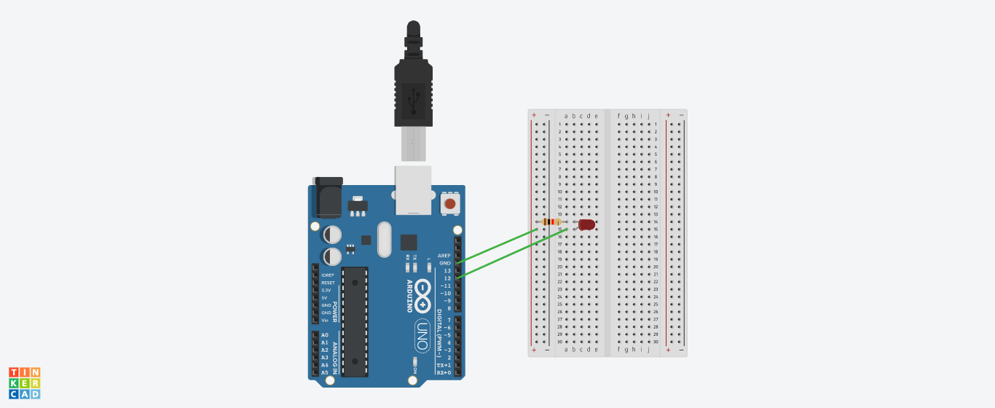

**THEORY**

**CONCEPT USED:-**

Here we will use the concept of breadboard, arduino UNO, LEDs and connections. We have connected positive terminal of LED with pin No. 12 in arduino UNO and negative terminal is connected to GND known as ground which act as negative terminal

KIRCHOFF’S CURRENT LAW:-

This law states that the current going in the junction is equals to the current flowing out of the junction.

KIRCHOFF’S VOLTAGE LAW:-

The sum of voltages in a loop is zero

These both laws help us to know about how to connect circuits in series and parallel

OHM’S LAW:-

It states that current through a conducter is directly proportional to the voltage across the two points provided that the physical condition such as temperature remains constant.

**V=IR**

**LEARNING AND OBSERVATION:-**

Blinking of LEDs was verified after uploading the program.1

1. We observed that LED glows and then goes off ,this will happen again and again and a flasher is formed
2. We learn that current always follows the shortest path to flow
3. We learn how to make various connection in series and parallel circuits
4. 4.We also learn making various connections of LEDs

**PROBLEMS AND TROUBLESHOOTING:-**

The problem faced while the task were:-

1. The pin No. was written wrong due to which the circuit is not working,this is the problem faced while making the circuit
2. The connections went wrong so I had to change the connections and that’s why LED was not blinking.
3. We have to connect negative terminal with resistor but it is connected wrong by me i.e. I connect it with wrong terminal

**PRECAUTIONS:-**

1. Double check the circuit to make sure all the components are in the right place.
2. Hands should not be wet while working with the circuits.
3. The circuit must be closed.
4. We have to attentive while making connections,otherwise it may go wrong and circuit will not work

**LEARNING OUTCOMES:-**

I learned that how we work with Arduino UNO and breadboard and how to make connectionsto start the blinking of LEDs.

I learned making circuits using different hardwares and controlling the functions done by circuit with the program.

I learned how to connect a simple LED in the circuit